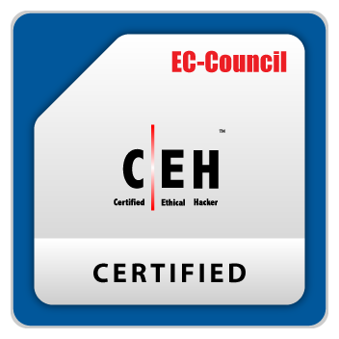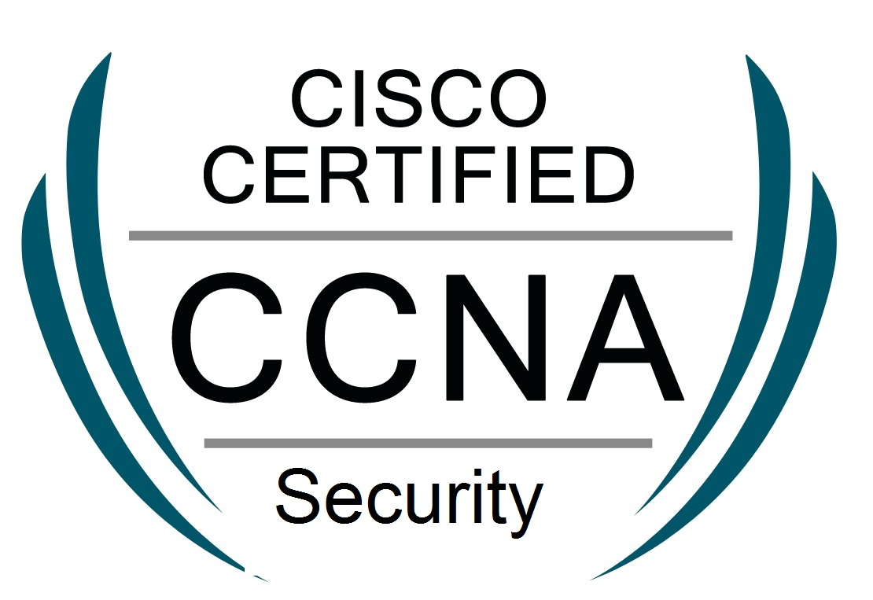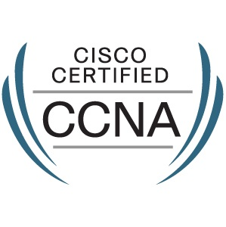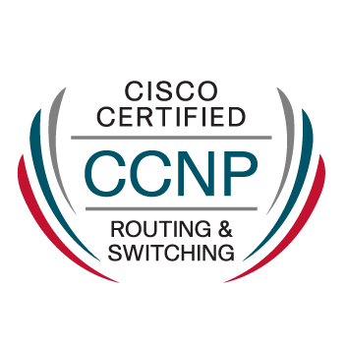

Professional Summary:
Shabeer Ibrahim
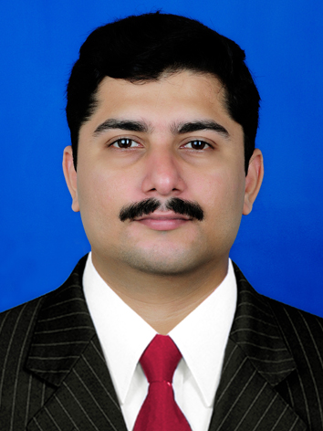
Mobile: +974 3390-8540
Email: shabeeribm@gmail.com
Skype: shabeeribm
Passport: S2365951
Location: Qatar
Relocation: Open

Experience On:
- Cisco Identity Services Engine (ISE)
- Cisco Stealthwatch
- CarbonBlack Protection
- CarbonBlack Response
- Cisco AMP
- Cisco Umbrella
- Cisco Threatgrid
- Cisco Ironport
- Qradar SIEM
- Bluecoat Proxy SG
- Symantec CAS
- Symantec MAA
- Symantec SSLV
- Symantec SOLERA
- Beyondtrust VA Scanner
- Thinkst canary box
- Cisco ASA Firewall
- Cisco Firepower
- Fortigate Firewall
- Palo Alto Firewall
- PRTG
- AD Audit Plus
- Incident Management
- Change Management
- Windows Forensics
- Memory Forensics

Cisco certified IT Engineer having experience with Cisco switches, Firewalls and other security devices

- Familiar with Cisco ISE, Cisco ASA /FortiGate /Palo Alto firewalls and Cisco Switches
- Familiar with EDR solutions like CarbonBlack response and Cisco AMP
- Familiar with monitoring devices like Qradar SIEM and Cisco Stealthwatch
- Excellent customer service skills and has experience in providing telephone, remote and email support to users.

Education and Trainings

- B-Tech in ECE from MES CE, Kuttipuram
- Implementing and Configuring Cisco Identity Services Engine (SISE) 3.0
- SANS FOR508: Advanced Digital Forensics, Incident Response, and Threat Hunting

Education and Certification

- Cisco Certified Network Associate (CCNA)
- Cisco Certified Network Associate (CCNA Security)
- Cisco Certified Network Professional (CCNP R&S)
- Certified Ethical Hacker (C|EH)

Professional Experience

Confidential, Qatar govt May 2016 – Present

Title: Network Security Engineer
- Plan, monitor, and implement security measures to protect organization’s computer systems, networks, and data
- Analyze and respond to hardware and software weaknesses and vulnerabilities
- Perform vulnerability assessments, security testing, and work with operations and development teams on remediation and mitigation of findings and to produce and deliver a cyber security analysis report
- Manage network Security devices including firewalls and EDR solutions
- Development of use cases for Qradar SIEM and Cisco Stealthwatch
- Worked on adding log sources/Creating offenses and custom regex searches in QRadar
- Making recommendations to management regarding security enhancements and improvements
- Monitoring systems and networks for intrusions or security breaches
- Conducting network scans to identify weaknesses or vulnerabilities
- Monitoring systems to identify irregular behavior
- Reporting findings and feedback to management
- Creating and analyzing Annual maintenance contract and BoQ for security products
- Actively Blacklisting/Whitelisting third-party software programs which has vulnerabilities using CarbonBlack Protection
- Configuration, Troubleshooting and maintenance of Cisco Identity Services Engine (ISE)
- Configured and Implemented 11 Thinkst Canary boxes in the network

Petrolink Data Services Ltd April 2014 – April 2016
www.petrolink.com

Title: ICT Engineer
- Work as a part of 24/7 support team responsible for technical support at the network level: WAN and LAN connectivity, Firewalls / VPN / Active Directory / Servers and Security issues
- Hands on experience with interface of CISCO ASA / Fortigate /Palo Alto firewalls
- Experience in configuring Cisco Anyconnect and Palo Alto Global protect and Windows VPN
- Experience in identifying , analyzing, and correcting security Incidence Including both user security and network security
- Familiar with creating and reviewing firewall rules
- Maintain and manage all objects in Active directory, Resolve AD account Lockouts etc
- Manage and secure corporate mobile phones using Maas360 MDM
- Monitor the entire IT infrastructure using tools and manage system alerts and notifications and respond accordingly to resolve the issues.
- Create, Maintain and manage Virtual machines using VMware Vsphere client.

CMC Limited, A TATA Enterprise http://www.cmcltd.com/ Nov 2013 – March 2014

CS-Network Support Engineer
End Client : Reserve Bank of India, Cochin
Project : IDRBT Leased Line FM and AMC Project
[Support for Cisco Routing/Security Solutions]

- Configure and maintain VLAN in RBI campus
- Involved in upgrading Networking devices
- Monitor network and Troubleshoot problems reported from users
- Assist users in Installing and upgrading banking software
- Provide training on Information Security to bank users
- Installed and maintained computer peripheral equipment such as scanners, printers, whiteboards, and projectors; to ensure that these are prepared and ready to be used.

NewAgeSys Solutions Private Ltd http://www.newagesys.com/ Dec 2010– Nov 2012

Sr Resource Specialist
- Administering and maintaining of Windows servers, Desktops, Switches and Firewall
- Set up user accounts, permissions, passwords and other security roles and features.
- Provide training about Information Security Awareness ,company policies and software to New Joiners
- Experience in recruiting consultants for Networking and systems related openings from our clients in USA

Clerysys, INC http://www.clerysys.com/ Dec 2007– Nov 2010
System Administrator
- Provide technical support for both hardware and software issues to users
- Monitor the system daily and respond immediately to security or usability concerns
- Administrate infrastructure, including firewalls, malware protection software and other processes

